Neater Mat - COLOR SIZE
ITEM #
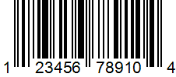
Neater Pet Brands
PO # XYZ
Made in India
Neater Mat - Gray
Small (16” x 10”)
415-206-01 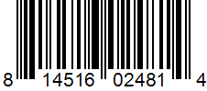
Neater Pet Brands
PO # 0020719
Made in India
Neater Mat - Gray
Medium (19” x 12”)
415-216-01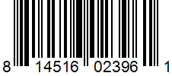
Neater Pet Brands
PO # 0020719
Made in India
Neater Mat - Gray
Large (24” x 16”)
415-236-01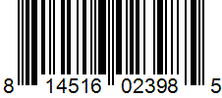
Neater Pet Brands
PO # 0020719
Made in India
Neater Mat - Gray
Extra Large (32” x 24”)
415-246-01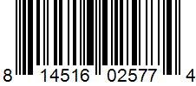
Neater Pet Brands
PO # 0020719
Made in India

